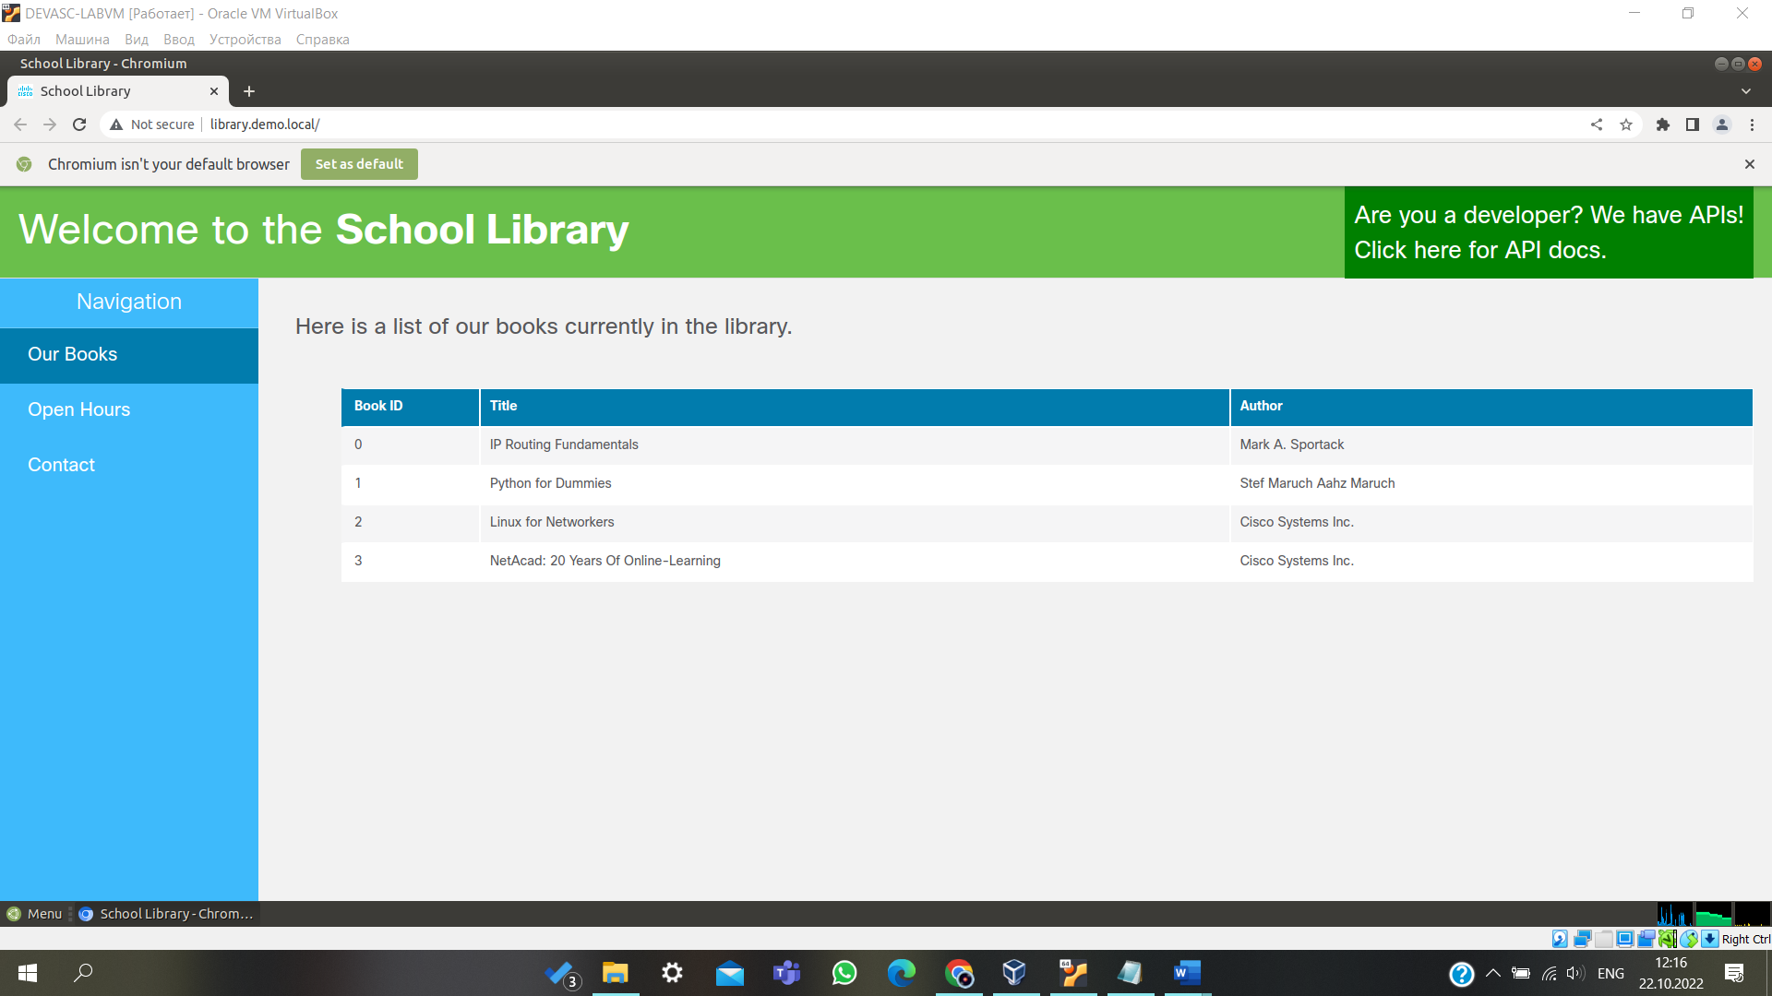

## Step 3: Go to the API docs page.

## Step 4: List books using the GET /books AP

## Step 6: Use the curl command in a terminal window.

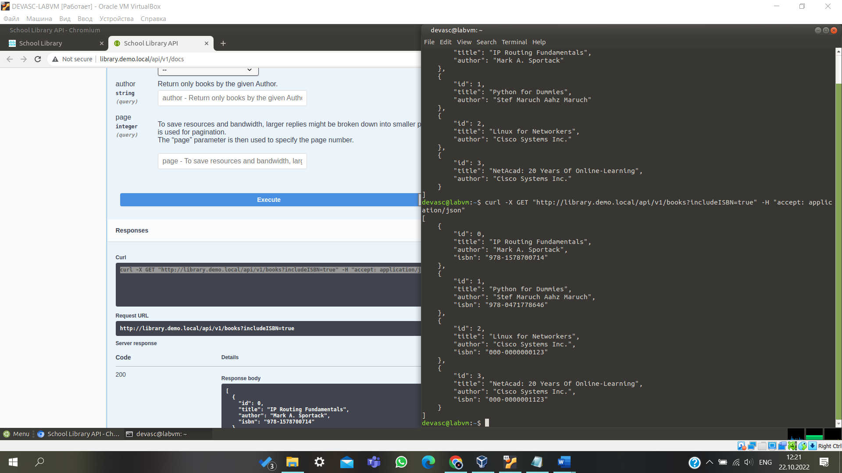

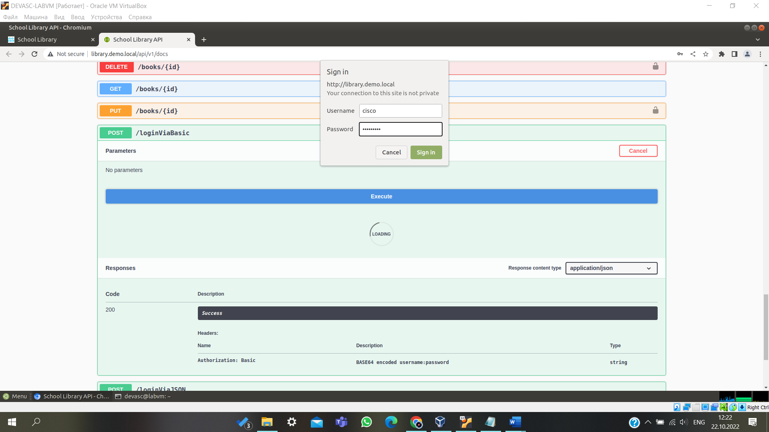

## Step 9: Add books using the POST /books API.

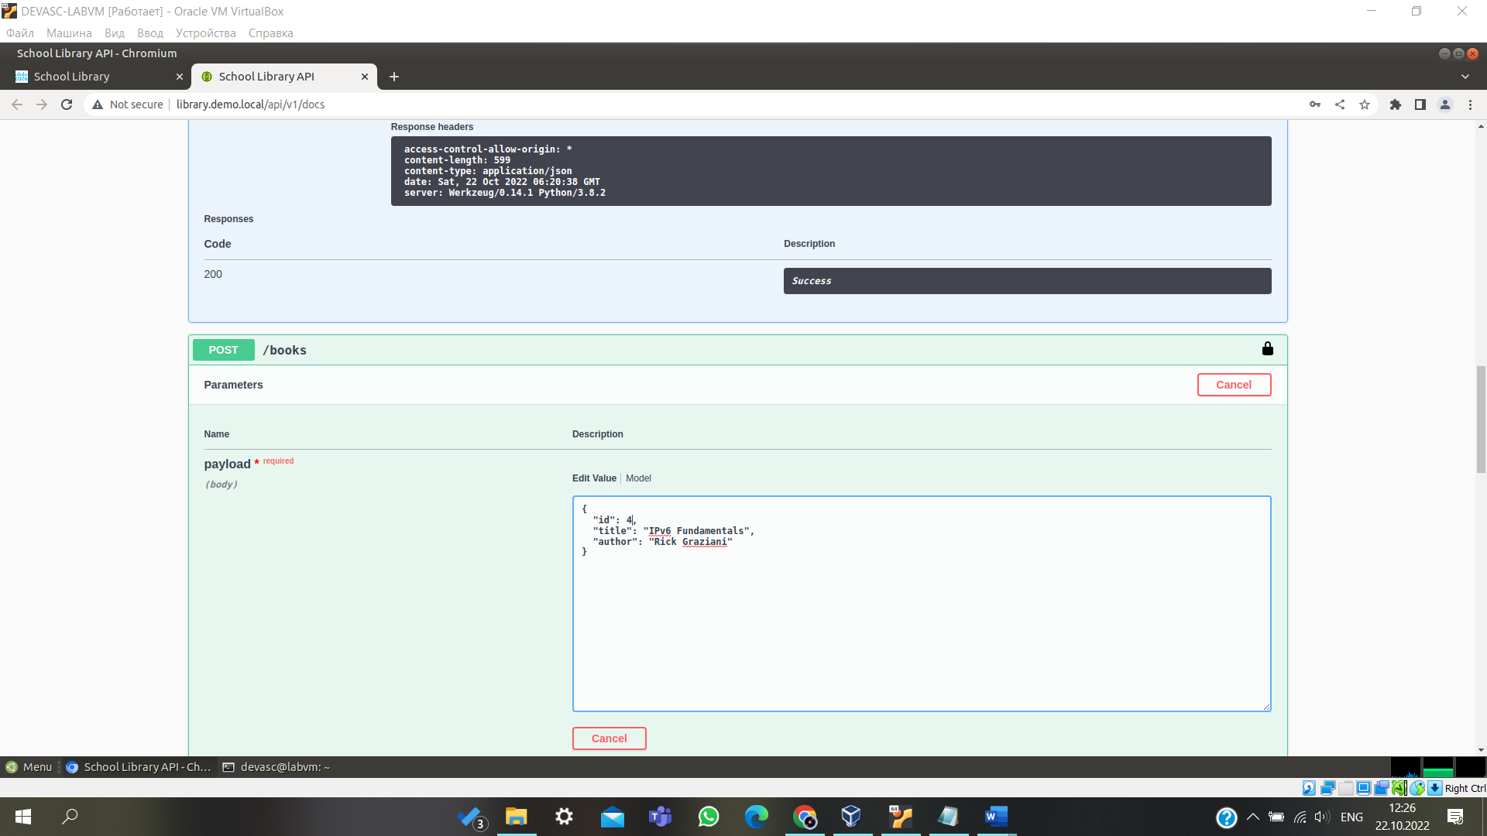

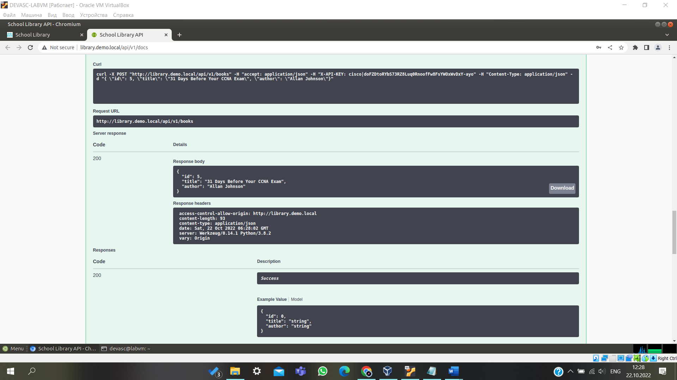

## Step 11: List a specific book using the GET /books{id} API.

## Step 12: Delete a specific book using the DELETE /books{id} API.

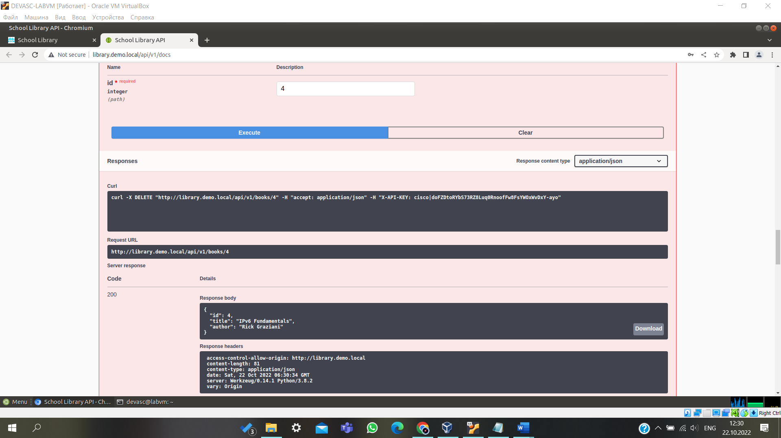

## Step 13: List books using the GET /books API.

# Part 3: Use Postman to Make API Calls to the API Simulator

In this Part, you will use Postman to make the same API calls you made in the Student Library API documentation. Postman is a useful tool when an API developer web site is not available while providing the ability to easily save, organize, and reuse APIs.

## Step 1: Open Postman.

## Step 3: Get a Token using the POST /loginViaBasic API.

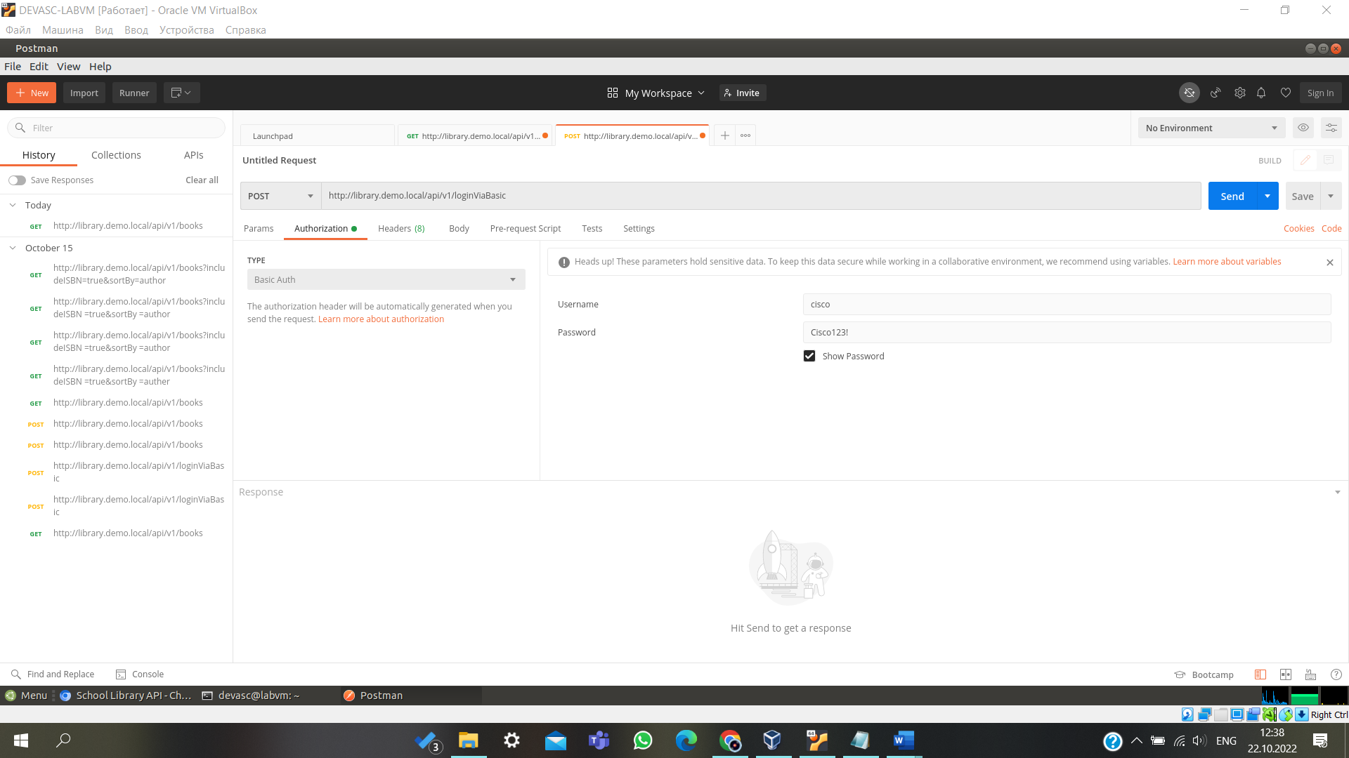

## Step 4: Add a book using the POST /books API.

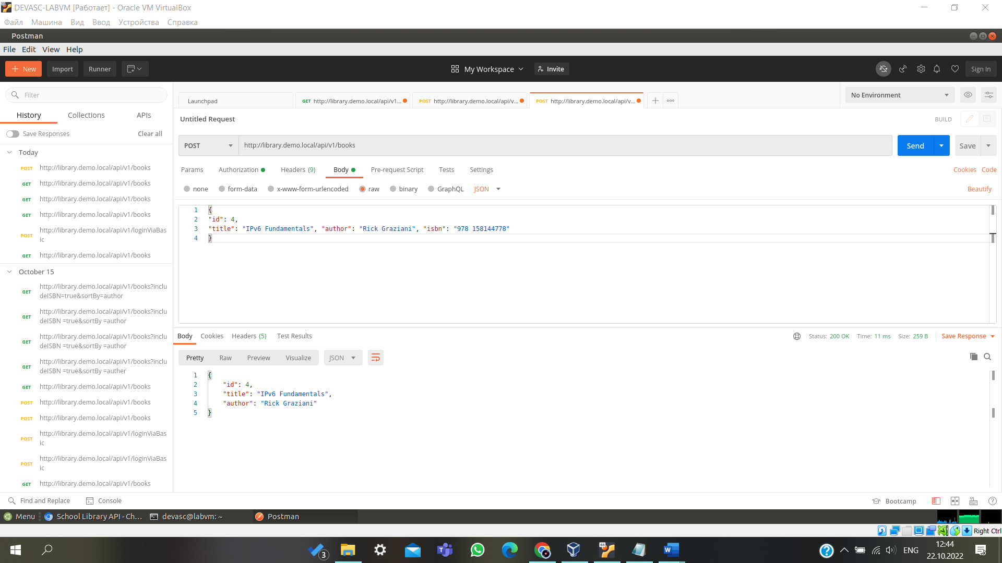

## Step 5: Verify the additional book with the Get /books API.

## Step 6: Use additional parameters with the Get /books API.

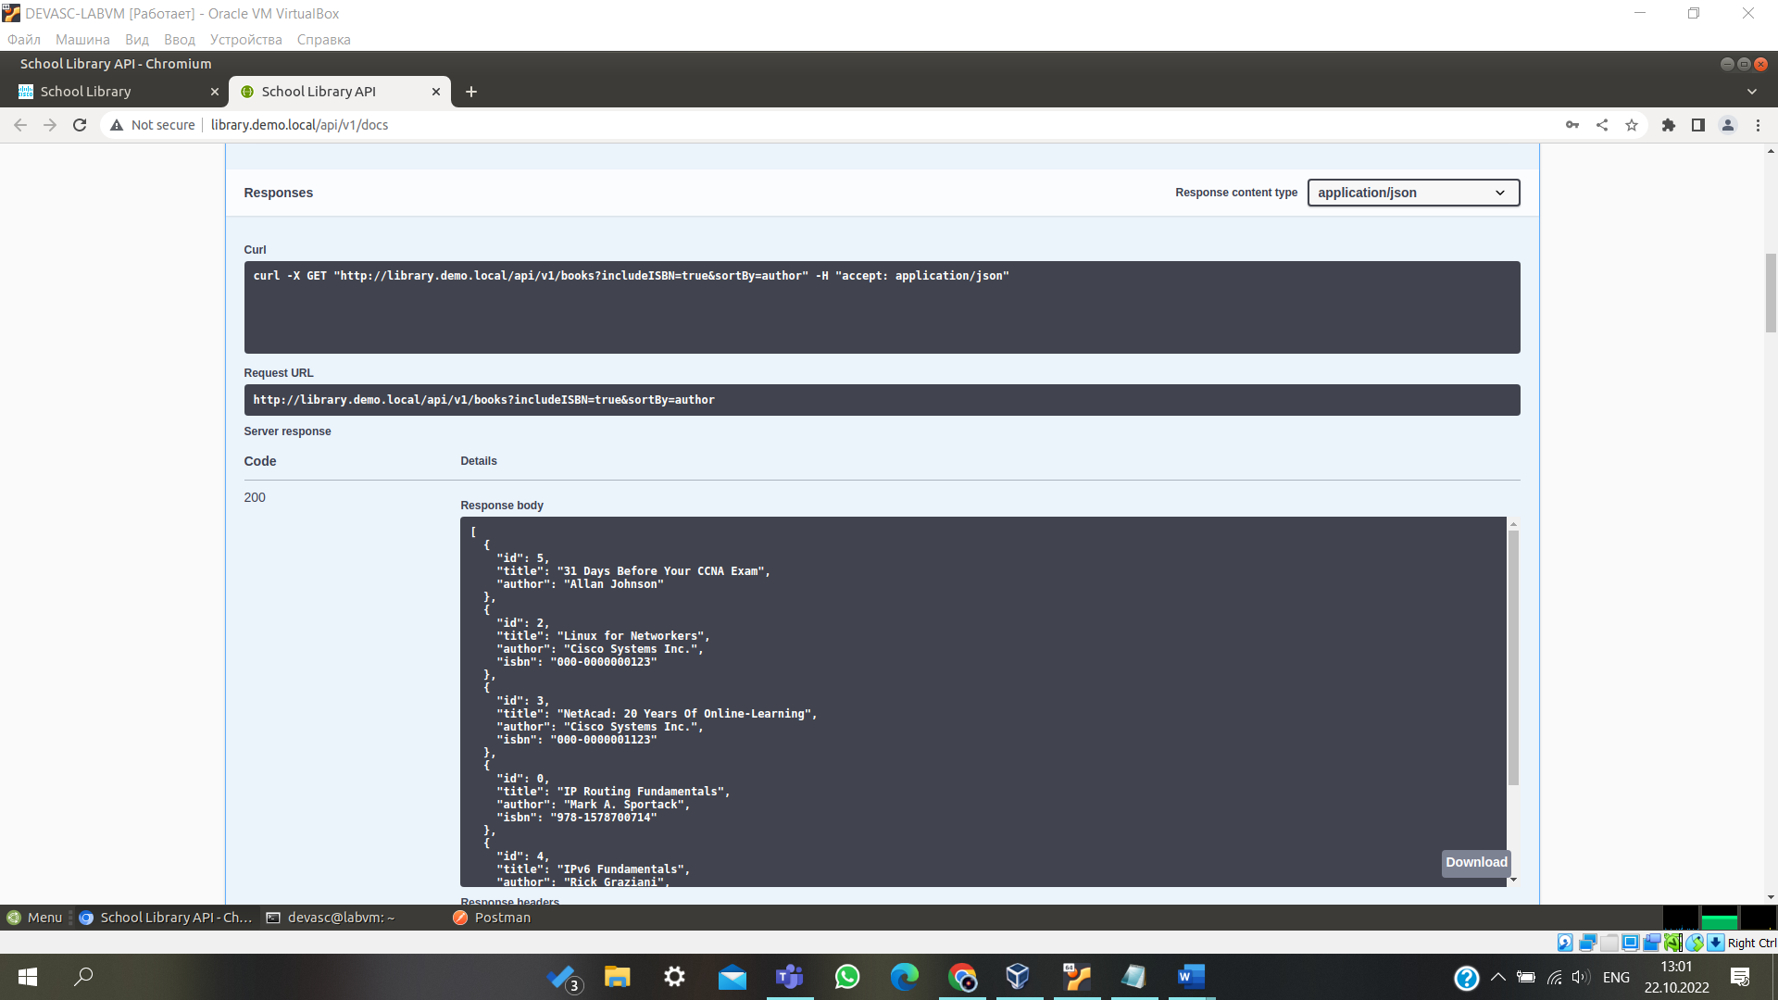

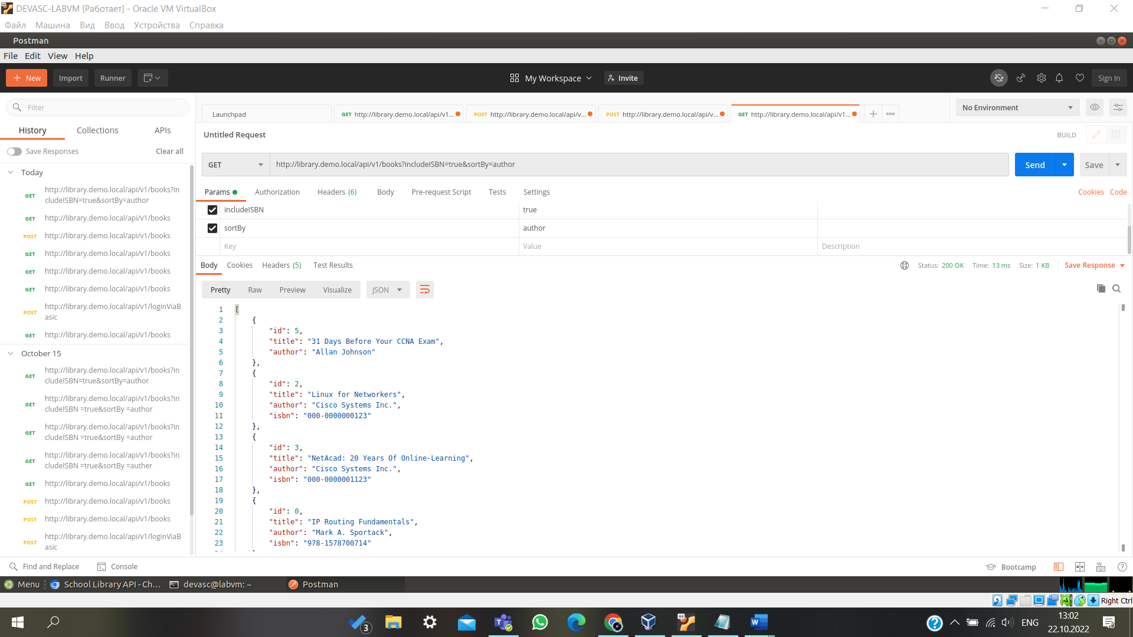

# Part 4: Use Python to Add 100 Books to the API Simulator

## Step 1: Open Visual Studio (VS) Code and navigate to the school-library directory.

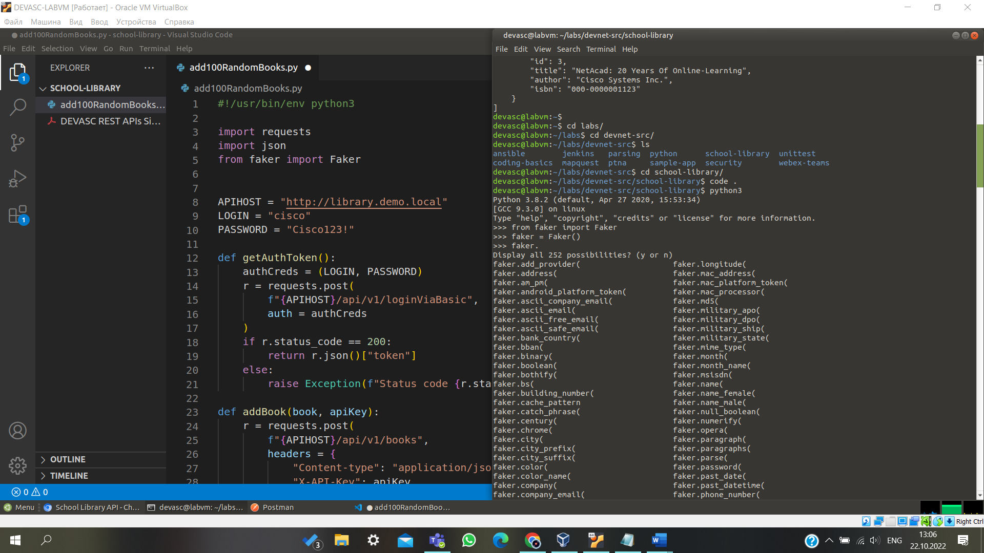

## Step 3: Practice generating random data using the faker library.

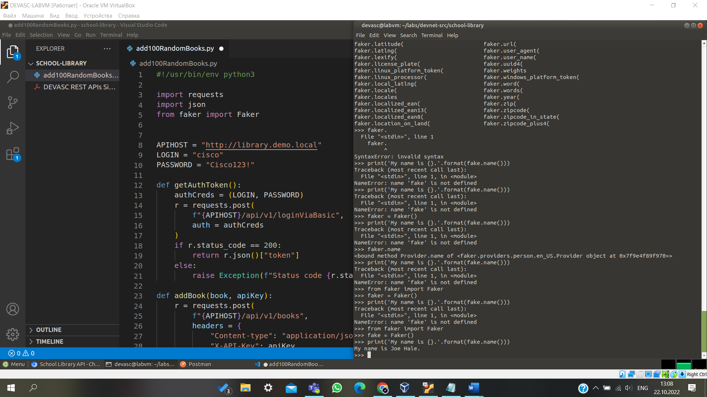

1. Return to the Chromium browser and refresh the [**http://library.demo.local/**](http://library.demo.local/) webpage. You should now see your 100 new books added.

**Note**: If you got to the API documentation page instead of the main page ([**http://library.demo.local/api/v1/docs**)](http://library.demo.local/api/v1/docs)) and use **Try It out**, you will only get a list of the first 10 books. You can enter a value from 2 to 10 the **page** parameter to see the other books.

How would you add another 100 books?

